James Crabbe教授简介
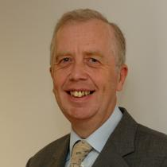
A former Governing Body Fellow of the College, Professor James Crabbe is Dean of Creative Arts, Technologies & Science at the University of Bedfordshire. He is also a Visiting Professor at the University of Reading, two Universities in China, and Chair of Governors of Central Bedfordshire Further Education College.
Crabbe's research on the impact of climate change on coral reefs and the people who depend on them. In 2006, he won the 6th Aviva / Earthwatch International Award for Climate Change Research. In 2008, he received the Award of Outstanding International Contribution to the Creative Industry of China. Crabbe is the Chairman of Trustee Directors of the Charity for Access Ability and Communications Technology (AACT), and a Trustee of the Guild of Benevolence of the Institute of Marine Engineering, Science & Technology, of which he is a Fellow.
https://www.wolfson.ox.ac.uk/content/1183-prof-james-crabbe

